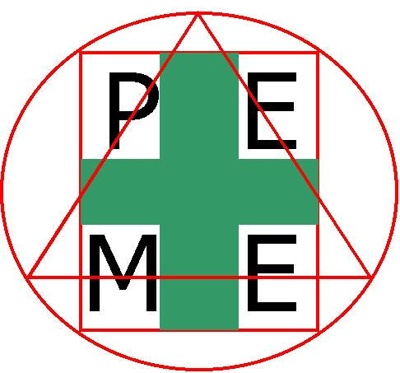  SINCE 2003 |  | PEME CONSULTANCY INC.  “We care for People Environment Materials & Equipment”  www.peme.org  DOLE Accreditation No. 1030-012020-0035  TIN 221-916-616-000 VAT
January 4, 2020

Attention: Authorized Managing Officer (AMO)
Senior Managing Officers
Senior Technical Employees (STE)
General Manager/Plant Manager
Project/Site Manager
Operations/Manufacturing Head
Human Resources Manager/Training Manager
Administration Manager/Facilities Head
Safety Officer/Practitioner
Members of the Safety & Health Committee

Subject: DOLE-DPWH-DTI/PCAB, DILG Prescribed training:

- Construction Occupational Safety & Health (COSH)
- Basic Occupational Safety & Health (BOSH)
- Advance OSH-Loss Control Management (LCM) with HIRAC
- Basic OSH Training for Safety Officer 1 (SO 1)
- Working at Heights, Rigging and Rescue Training

Greetings in the Name of Health and Safety!

PCAB License Required Training – Renewal and New
Prescribed Training Course for Authorized Managing Officer (AMO); Sustaining Technical Employees and Safety Officers Compliance to: DEPARTMENT OF LABOR AND EMPLOYMENT
- Department Order (DO) No. 198-18 re Implementing Rules and Regulations of Republic Act No. 11058 “Strengthening Compliance to Occupational Safety and Health Standards and providing penalties thereof”
- Department Order No.13 “Guidelines Governing Occupational Safety and Health in the Construction Industry”
- All Contractors and Sustaining Technical Employees (STE) must complete a 40-hour safety training course. The completion of such a course is a prerequisite for license renewal for the license. (PCAB Board Resolution No. 425 series of 2015)

Under Rule 1033 of Philippine Occupational Safety and Health Standards (as amended) and DO 16 series of 2001, to wit “The minimum qualifications, duties and number of required safety and health officers shall be as follows: 1) All safety officers must complete the Bureau-prescribed training course prior to their appointment as in their respective places of employment; 2) All full-time safety officers must meet the requirement of duly-accredited Safety Practitioners or Safety Consultants by the Bureau; and 3) Not less than the following number of supervisors or technical personnel shall take the required trainings and shall be appointed as a safety officer on a full-time or part-time basis, depending on the number of workers employed and the hazardous or non-hazardous nature of the workplace.”

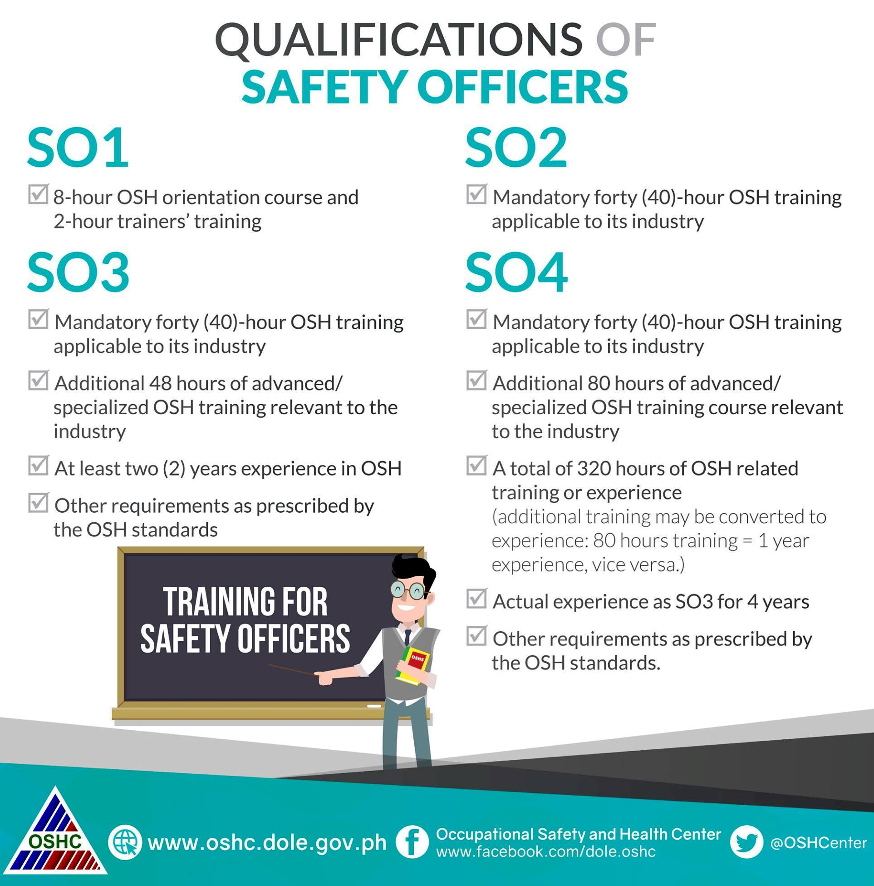
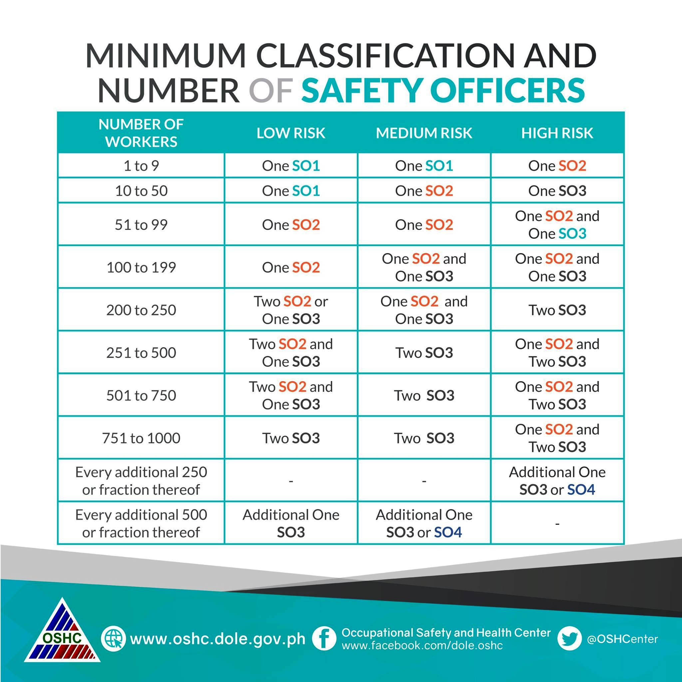
PEME Consultancy Inc., an accredited Safety Training Organization (STO) of the DOLE-OSHC, believes that health and safety should be available for all. It is for this reason that we would like to invite your employees to attend our Public Training Course (PTC).
Month | Day/s | Training Course
January | 18-22 (Mon-Fri)  WEBINAR | Construction Occupational Safety & Health (COSH)*SO2
January | 25-29 (Mon-Fri)  WEBINAR | Basic Occupational Safety & Health (BOSH)*SO2
January | 30-31 (Sat-Sun)  WEBINAR | Mandatory Basic Occupational Safety and Health Training for Safety Officer 1 (SO1)
February | 1-5 (Mon-Fri)  WEBINAR | Construction Occupational Safety & Health (COSH)*SO2
February | 15-19 (Mon-Fri) WEBINAR | Basic Occupational Safety & Health (BOSH)*SO2
March | 3-4 (Thu-Fri)  WEBINAR | Mandatory Basic Occupational Safety and Health Training for Safety Officer 1 (SO1)
March | 8-12 (Mon-Fri) WEBINAR | Basic Occupational Safety & Health (BOSH)*SO2
March | 15-19(Tue-Fri) WEBINAR | Construction Occupational Safety & Health (COSH)*SO2
March | 22-26(Tue-Fri)  WEBINAR | Loss Control Management (LCM) – Advanced OSH*& HIRAC (SO3)
April | 7-8 (Wed-Thu)  WEBINAR | Mandatory Basic Occupational Safety and Health Training for Safety Officer 1 (SO1)
April | 12-16 (Mon-Fri)  WEBINAR | Construction Occupational Safety & Health (COSH)*SO2
April | 19-23 (Mon-Fri)  WEBINAR | Basic Occupational Safety & Health (BOSH)*SO2
April | 26-30 (Mon-Fri)  WEBINAR | Loss Control Management (LCM) – Advanced OSH*& HIRAC (SO3)
May | 17-21 (Mon-Fri)  WEBINAR | Construction Occupational Safety & Health (COSH)*SO2
May | 24-28 (Mon-Fri)  WEBINAR | Basic Occupational Safety & Health (BOSH)*SO2
June | 9-10 (Wed-Thu)  WEBINAR | Mandatory Basic Occupational Safety and Health Training for Safety Officer 1 (SO1)
June | 14-18 (Wed-Thu) WEBINAR | Basic Occupational Safety & Health (BOSH)*SO2
June | 21-25 (Mon-Fri)  WEBINAR | Construction Occupational Safety & Health (COSH)*SO2
July | 5-9 (Mon-Fri)  WEBINAR | Loss Control Management (LCM) – Advanced OSH*& HIRAC (SO3)
July | 12-16 (Mon-Fri) WEBINAR | Basic Occupational Safety & Health (BOSH)*SO2
July | 21-22(Wed-Thu)  WEBINAR | Mandatory Basic Occupational Safety and Health Training for Safety Officer 1 (SO1)
July | 26-30 (Mon-Fri)  WEBINAR | Construction Occupational Safety & Health (COSH)*SO2
August | 16-20 (Mon-Fri)  WEBINAR | Basic Occupational Safety & Health (BOSH)*SO2
August | 23-27 (Mon-Fri)  WEBINAR | Construction Occupational Safety & Health (COSH)*SO2
September | 1-2 (Wed-Thu) WEBINAR | Mandatory Basic Occupational Safety and Health Training for Safety Officer 1 (SO1)
September | 13-17(Mon-Fri) WEBINAR | Basic Occupational Safety & Health (BOSH)*SO2
September | 20-24 (Mon-Fri) WEBINAR | Construction Occupational Safety & Health (COSH)*SO2
October | 4-8 (Mon-Fri)  WEBINAR | Loss Control Management (LCM) – Advanced OSH*& HIRAC (SO3)
October | 11-15 (Mon-Fri) WEBINAR | Basic Occupational Safety & Health (BOSH)*SO2
October | 25-29 (Mon-Fri)  WEBINAR | Construction Occupational Safety & Health (COSH)*SO2
November | 10-11 (Wed-Thu)  WEBINAR | Mandatory Basic Occupational Safety and Health Training for Safety Officer 1 (SO1)
November | 15-19 (Mon-Fri)  WEBINAR | Construction Occupational Safety & Health (COSH)*SO2
November | 22-26 (Mon-Fri)  WEBINAR | Basic Occupational Safety & Health (BOSH)*SO2
December | 6-10 (Mon-Fri)  WEBINAR | Basic Occupational Safety & Health (BOSH)*SO2
December | 13-17 (Mon-Fri)  WEBINAR | Construction Occupational Safety & Health (COSH)*SO2

REGISTRATION FEE Per Delegate:
- SO1- Eight(8) Hour plus Two(2) Hours TOT: (Php1,500.00) Plus 12% VAT
- SO2- COSH, BOSH,SPA: (Php5,000.00) Plus 12% VAT
- SO3- LCM with HIRAC: (Php6,000.00) Plus 12% VAT
- Working at Heights, Rigging and Rope Rescue Training : (Php2,000.00)
WAH - (Lecture, Written and Actual demonstration)

The registration fee is inclusive of the following:
- E-learning Manual
- Identification Card (Qualified Safety Officer 1, 2 & 3)
- Certificate of Completion (in accordance with OSHC-DOLE Standards)

Why our training is unique?
- The latest ideas and best practices you can use to design, develop and enhance your existing OSH Program
- Focus on new approaches that are being adopted and sharing tools that will help you make real improvements
- Practical and interactive games that will provide a unique learning experience in a relaxed and informal environment
Participants will receive a training that will be like no other: concise, understandable and extremely applicable as we apply the latest training techniques and methodologies called “Accelerated Learning”. The use of “Accelerated Learning” in creating the right environment will ensure that all senses are stimulated, thereby more effectively ensuring learning is committed to memory in a way that is both creative and enjoyable.

ONLINE TRAINING PROTOCOLS:
Participants are required to:
1. Use Either a laptop or desktop with an internal/external webcam and microphone; Mobile devices such as phones or tablets will not be allowed.
2. Use Latest update of Google Chrome installed;
3. Have stable internet connection with enough load for 8-9 hours session per day;
4. Be in a classroom setting; turn-on their video for recording and monitoring for the entire session; Complete the 8 hours module;
5. Participants should be on the line on the application that will be used for the meeting 5 to 10 minutes before the registration starts.
6. The participants will be asked to check their connectivity, avoid boisterous surroundings, etc. for them to avoid unnecessary disturbance during the training.8. Most of all, the participants shall be validated if the person attending is truly the person registered. During checking, they will be asked to provide at least one Identification Card (Government or Company ID).
7. Wear a decent attire for the whole day and kindly broadcast your webcam.

NOTE: Failure to comply, participants will be removed during the session and need to retake the training.

INTRODUCING THE PHILIPPINES’ MOST EXPERIENCED SAFETY AND HEALTH CONSULTANTS AND PRACTITIONERS-YOUR RESOURCE SPEAKERS:

- Mr. Joel B. Ello
- Mr. Josefino C. Adajar
- Dra. Jocelyn D. Santiago
- Dr. Neil P. Rodrigo
- Mr. Frumencio “Ming” Tan
- Mr. Filipino Ilagan
- Mr. Neal Martinez
- Mr. Marx C. Pranada

TRAINING COURSE INFORMATION AND WAYS TO REGISTER
You may also deposit your registration fee to BDO account name: PEME Consultancy, Inc./SA# 00554-0224-028 and email to consultancy@peme.org copy of the deposit slip together with the completed registration form.

NOTE: Cancellation of registration shall be charged 50% for administrative cost and other expenses.

- - - - - - Please email this form to
Ms. Den E. Yabes
Ms. Maryann & Ms. Ethel
 Tel No. (02) 8245-1561/ 8806-6504
Telefax (02) 8477-6973, 8661-3571
 consultancy@peme.org
Mobile Nos. 0977-877-7715/0917-886-7363

Contact Contact Person:_____________________________ Designation: _______
C
Company:_______________________ Address:___________________________________
_______
Tel #:________________ Fax #: __________________ E-mail: __________
Name of Participant/s | Nickname | Position | Mobile No. | TRAINING DATE | TRAINING COURSE
1
2
3

DATA PRIVACY POLICY

PEME Consultancy Inc., is bound by Republic Act No. 10173, or the Data Privacy Act of 2012, as well as other laws that imposed specific obligations in regard to handling personal information that directly or indirectly identifies a person. The privacy policy and principles in this document are in accordance with these laws.

PEME Consultancy Inc., is committed to protecting the privacy of personal information. This Privacy Policy embodies this commitment.

The Policy supports the Republic Act No. 10173, or the Data Privacy Act of 2012 need to collect information and the right of the individual to privacy. It ensures that the PEME Consultancy Inc., can collect personal information necessary for its services and functions, while recognizing the right of individuals to have their information handled in ways that they would reasonably expect and in ways that protect the privacy of their personal information.

SCOPE

This policy applies the use of audio and/or video monitoring and/or recording systems intended for the regulatory requirements of DOLE-OSHC.

Personal information is collected and used by PEME Consultancy Inc., for the following purposes:

- to provide services or to carry out the training properly functions;

- to evaluate services and functions;

- to comply with DOLE-OSHC regulations and other regulatory requirements;

- to investigate incidents or defend any legal claims against the services;

PEME Consultancy Inc., has adopted the information privacy developed by the Republic Act No. 10173, or the Data Privacy Act of 2012 as minimum standards in relation to handling personal information.

In broad terms, this means that PEME Consultancy Inc.:

- collect only information which is required for a specified primary purpose;

- ensure that the person supplying the information knows why the information is collected and how it will be handled.

REVIEW OF THE QUALITY ASSURANCE AUDIO/VIDEO RECORDING POLICY

Department Directors requesting authorization to use audio/video recording devices are responsible for the implementation of the policy with their staff to ensure compliance.

VIDEO/AUDIO TAPE CONSENT FORM

As part of our aim in offering a high quality service, we have found it helpful to the work that people do with us to make recordings of sessions. Review of tapes usually furnishes us with more ideas that you might find helpful in your circumstances. It is also sometimes helpful in training people who are learning.

Please read the following paragraphs and, if you are in agreement, sign where indicated,

- I/We consent to video/audio tapes being made of these sessions and to these tapes being used to aid the training.

- I/We consent to excerpts from these recordings, or descriptions of them, being used by the PEME Consultancy Inc., staff for the purposes of supervision, research and/or teaching.

I/We understand that the PEME Consultancy Inc., staff will edit out from these recordings, or from descriptions of the recordings, as much identifying information is possible.

On behalf of the PEME Consultancy Inc., I undertake that, in respect of any video/audio tapes made, every effort will be made to ensure professional confidentiality and that any use of video/audio tapes, or descriptions of video/audio tapes, will be for professional purposes only and in the interest of improving professional standards through research or training programs. Every effort will be made to protect the anonymity of all those involved in the sessions.

Printed Name of Participant: __________________________________________________

Signature: ________________________________________________________________

Date: _________________________

Note: Kindly submit this Data Privacy Consent Form together with the accomplished Registration Form, Identification Card (Government or Company ID), 2x2 picture with white background and a copy of proof of payment.

Mandatory Basic Occupational Safety and Health (OSH) Training Course for
Safety Officer 1 (SO1) with Two (2) Hour Training the Trainers

Terminal Objective: To provide the participants the basic knowledge and skills on the basic concepts and principles of occupational safety and health (OSH) that will enable safety officers to develop and implement their company’s safety and health program.

LEARNING ROAD MAP
Methodology of training is through Lecture/discussions, exercises, workshop, Video Showing, presentation/reporting

Module 1: Overview  Objectives: Participants will be able to appreciate OSH and know the importance of various data and legislations relating to OSH | 1 hour
I. Introduction to OSH  - Importance of OSH  - Situationer using company data/statistics  - Salient features of OSH Legislations  1. RA 11058 and its IRR (DO 198-18)  2. OSH Standards as amended including related provisions of PD 626 and with emphasis on duties of OSH Personnel and HSC | 1 hour
Module 2: Understanding OSH  Objectives: Participants will be able to understand and apply concepts on OSH in their workplaces | 2 hours
II. General Concepts on OSH  - Accident Causation Theories (ex. Domino Theory)  - Accident Causation and Prevention  1. Unsafe Act and Unsafe Conditions  2. Accident Prevention  3. Benefits of having Safety and Health Practices in the Workplace | 2 hours
III. Definition of Terms with examples
- Safety Hazards
- Health Hazards
- Covid-19
- Risks
1. Low Risks
2. Medium Risks
3. High Risks
Module 3: Knowing Safety Hazards and Controls  Objectives: Participants will be able to know and apply basic safety concepts in their workplaces | 2 hours
IV. Basic Safety Concepts and Principles  - Housekeeping and Materials Handling and Storage  - Machine Safety (Types, Sources and Control)  - Electrical Safety (Types, Sources, LOTO and Controls)  - Fire Safety (Elements of Fire, Prevention and Control)  - Chemical Safety  - Workshop  Application of Learning | 2 hours
Module 4: Hazards Identification, Risk Assessment and Control (HIRAC)  Objectives: Participants will be able to identify hazards with its accompanying risks and participants to recommend measures of control | 2 hours
V. Hazards Identification, Risk Assessment and Control (HIRAC)  - Key steps in recognizing and identifying hazards  1. Safety Hazards  2. Health Hazards  - Risk Assessment and Prioritization  - Application of Controls (Elimination, Substitution, Engineering,  Administrative & PPE)  - Workshop on Accomplishing Risk Assessment Form/Matrix | 2 hours
Module 5: Workplace Emergency Preparedness  Objectives: Participants will be able to know how to respond in workplace emergencies and participate during conduct of emergency drills | 1 hour
VI. Workplace Emergency Preparedness  - Roles of OSH Personnel  - Responses during Emergency  - Conduct of Emergency Drills (i.e. Earthquake Drill/Fire Drill/Bomb Threat) | 1 hour
Module 6: Administrative OSH Requirements  Objectives: Participants will be able to identify the prescribed administrative requirements and the provided penalties for violations | 30 minutes
VII. Administrative OSH Requirements  - Reportorial Requirements and Prescriptive Period of Submission (R1020, AEDR, WAIR, AMR, RSO & Minutes of Meeting)  - Mandatory OSH Programs  - Penalties for violations  - Post Test | 30 minutes
Module 7: Capacity Building of Trainers on OSH  Objectives: Participants will be able to confidently deliver OSH topics for presentation | 2 hours (recommended to take the TOT on separate day)
VIII. Training the Trainers  - Objective Setting  - Preparing Presentation Materials  - Basic Skills in Presentation | 2 hours (recommended to take the TOT on separate day)
- Commitment Setting (Re-entry Plan)

CONSTRUCTION OCCUPATIONAL SAFETY and HEALTH (COSH)

LEARNING ROAD MAP
Methodology of training is through Lecture/discussions, exercises, workshop, Video Showing, presentation/reporting

Course outline | Duration
Setting the Learning Climate  - Leveling of Expectations  - Introduce OSH  - Explain the General Course Objectives | 1 hour and 30 minutes
Module 1 – Importance of Safety and Health  - Explain the current Philippine OSH Situation  - Describe the OSH Situation in their own workplaces  - Define unsafe/unhealthy acts and conditions | 1 hour and 15 minutes
Unsafe Act/Unsafe Condition Workshop…………………………….. | 1 hour
Module 2 – OSH Legislations  - Explain the government OSH regulations and other responses to existing and potential OSH hazards;  - Discuss the various strategies for OSH Administration in the  - Philippines; and  - Identify the different OSH reportorial requirements and areas for compliance to the OSH Standards. | 1 hour and 45 minutes
Module 3- Construction Site Premises  - Safe Work Method Statement / Safe Work Practices  - Educate on Basic Site HSES Rules & Regulations | 1 hour and 15 minutes
Module 4- Excavation Safety  - Provides practical guidance to manage health and safety risks associated with excavation work. | 1 hour and 15 minutes
Module 5 – Tools and Equipment  - To give proper instruction in the safe use and maintenance of tools and equipment | 1 hour and 15 minutes
Module 6 – Construction Machinery (Mobile Equipment)  - Lifting equipment, hoists, lifting gears with emphasis on crane operation  - Routine inspection of construction machinery  - Inspection and Testing Certification | 1 hour and 45 minutes
Module 7 - Construction Machinery (Crane Safety)
- To equip participants with the knowledge on basic crane operation and rigging associated with the operation of cranes.
- To provide instruction on the safe rigging and operation of cranes and hoisting units.
Module 8 – Fall Protection, Working at Heights  - Describe working conditions where fall protection is required  - Identify the components of a personal fall arrest system  - Demonstrate how to don and doff a full body harness  - Inspect and care for personal fall arrest systems before and after use | 1 hour and 15 minutes
Module 9 – Temporary Structures (Lecture)  - To enhance the knowledge and skills of the participants on Scaffolds Safety including erection/installation and inspection of Scaffolds, Working safety on heights including rescue and basic standard safety procedures on handling ladders and eventual certification from TESDA NC II as Scaffold Erector and competent person in compliance to Department Order No. 128-13 of the Department of Labor and Employment | 2 hours
Module 10- Temporary Structures (Erection)
Module 11 – Environmental Safety  - Monitoring of Occupational Health Hazards  - Common Methods for control of various Occupational Health Hazards | 2 hours
Module 12 – Occupational Health | 2 hours
Module 13- COVID-19 Prevention and Control in the workplace  - COVID-19 Medical Information (Pathophysiology, S/Sx)  - DTI /DOLE Interim Guidelines on Workplace Prevention & Control of COVID-19  - Roles of Safety Officers in the New Normal  - Facility Disinfection Procedures  - COVID-19 PPE Requirements  - Ingress Procedures, Distancing Strategies & Crowd Management  - Handling of Confirmed & Suspected Cases  - Mental Health Awareness | 1 hour
Module 13 - Demolition Safety  - To establish a safe work procedure during demolition operations. | 1 hour and 15 minutes
Module 14 – Personal Protective Equipment  - Principles and Applications | 1 hour and 15 minutes
Module 15 – Routine Site Safety Inspection  - To instruct the participant on identifying unsafe acts & conditions in the workplace before these turn into accidents or work-related illness. | 1 hour
Module 16 – Presentation of Inspection Results Workshop………….. | 1 hour and 30 minutes
Module 17 – Job Hazard Analysis
- To teach the participant how to analyze jobs in the workplace and spot possible sources of accidents in these different tasks.
Module 18 – Accident Causation (Risky Workplace and Risky Workers): Accident Investigation  - Discuss the importance of accident investigation.  - Enumerate the types of accidents to be reported.  - Explain the basic procedure in the conduct of accident investigation.  - Know how to document an accident investigation.  - Accomplish the Work Accident/Illness Report (WAIR) and Annual Accident/ Illness Exposure Data Reports (AEDR) based on cases given  - Compute sample Severity Rate (SR) and Frequency Rate (FR) | 2 hours and 45 minutes
Module 19 – Tool Box Meeting  - To perform new tasks safely, reminders for old tasks not recently performed, and an opportunity to discuss possible safety issues that have arisen on the job | 1 hour
Module 20 – Role of Safety Officers  - Seeking to utilize knowledge of health, safety and environmental protocols to foster compliance with safety procedures and protocols, and ensure a safe work place at all times | 1 hour
Module 21 - Communicating OSH  - Explain the roles of safety officers in the conduct of OSH trainings;  - Enumerate and discuss the stages of the training cycle;  - Discuss basic presentation and facilitating skills; and  - Prepare a training plan for their company. | 2 hours
Module 22 - Responses to OSH Issues and Concerns  - Workplace Emergency Preparedness  - Define what is emergency (natural/ man-made) and disaster  - Identify the elements of an effective Emergency Preparedness Program;  c. Enumerate basic preparations for common emergencies; and  d. Discuss the concept on Fire Brigade Organization. | 1 hour and 30 minutes
Module 23 - Employee’s Compensation Program  - Discuss the employee’s compensation programs, entitlement and benefits. | 1 hour and 30 minutes
Module 24 - OSH Program Development  - Identify the elements of the DOLE prescribed OSH program;  - Explain the roles, commitment and participation of various levels of the organization in implementing the OSH program; and  - Review how to fill out the DOLE reportorial requirements correctly. | 2 hours and 30 minutes
Module 25 - Workplace Emergency Preparedness  - Define what is emergency (natural/ man-made) and disaster  - Identify the elements of an effective Emergency Preparedness Program;  c. Enumerate basic preparations for common emergencies; and  d. Discuss the concept on Fire Brigade Organization. | 1 hour and 45 minutes
Unfreezing Activities | 1 hour and 30 minutes
Snack/Coffee Breaks | 1 hour and 30 minutes
Registration, Opening, Pre- test, Post Test, Re-Entry Planning, Evaluation and Closing | 2 hours and 15 minutes
Total number of hours: | 40 hours

BASIC OCCUPATIONAL SAFETY AND HEALTH (BOSH)

LEARNING ROAD MAP

Course outline | Duration
Setting the Learning Climate  - Leveling of Expectations  - Introduce OSH  - Explain the General Course Objectives | 1 hour and 30 minutes
Module 1 – Why the need for OSH?  - Explain the current Philippine OSH Situation  - Describe the OSH Situation in their own workplaces  - Enumerate the roles of Safety Officers in OSH implementation  - Identify the Risk Assessment steps/processes; and  - Define unsafe/unhealthy acts and conditions | 1 hour and 15 minutes
Module 2 – Workplace Risk Assessment  I-A. Workplace Safety Hazards  a. Describe hazards from poor housekeeping  b. Explain the causes and extent of fire incidents  c. Identify causes and effects of machine related accidents  d. Identify common hazards associated with materials handling  e. Enumerate common electrical hazards; and  f. Develop control measures against hazards in the workplace  before accidents and injuries can occur | 2 hours and 30 minutes
I-B. Workplace Health Hazards  - Explain the principles of Industrial Hygiene, and  - Identify health hazards in their workplace | 1 hour and 15 minutes
COVID-19 Prevention and Control in the workplace  - COVID-19 Medical Information (Pathophysiology, S/Sx)  - DTI /DOLE Interim Guidelines on Workplace Prevention & Control of COVID-19  - Roles of Safety Officers in the New Normal  - Facility Disinfection Procedures  - COVID-19 PPE Requirements  - Ingress Procedures, Distancing Strategies & Crowd Management  - Handling of Confirmed & Suspected Cases  - Mental Health Awareness | 1 hour
Workshop 1: Hazard Identification-Identify specific safety and health  Hazards | 2 hours
II-A. Workplace Environment Measurement  - Discuss Work Environment Measurement (WEM) and its importance in evaluating the hazards in the workplace and monitoring exposure of workers;  - Comply with industrial hygiene – related OSHS provisions and other issuances, laws and guidelines; and  - Explain the Threshold Limit Values (TLV) and its importance in evaluating workers’ exposure. | 1 hour and 30 minutes
II-B. Medical Surveillance  - Discuss medical surveillance and biological monitoring as strategies in examining health conditions of workers.  - Explain the role of these strategies in preventing Occupational illnesses.  - Describe the different steps in conducting medical surveillance. | 2 hours and 15 minutes
II-C. Workplace Risk Assessment  - Discuss the importance and goal of risk assessment;  - Determine how to use the risk matrix and risk ratings upon identifying hazards in the workplace;  - Conduct workplace risk assessment;  - Determine classification of risk level of workplace  Workshop 2: Risk Assessment- Conduct a sample assessment using  DOLE Prescribed template | 1 hour and 30 minutes
III-A. Control Measures of Health Hazards  - Discuss the general principle of controlling health hazards in the workplace; and  - Identify the different methods of control and their importance in the control of health hazards. | 1 hour and 45 minutes
III-B. Control Measures of Safety Hazards  - Explain the value of practicing good workplace housekeeping;  - Explain the principles of fire prevention, suppression and control;  - Enumerate ways of machine safeguarding;  - Demonstrate safe method of manual lifting and handling of materials;  - Identify the appropriate and approved types of PPE needed in a workplace; and  - Enumerate the steps in conducting job hazard analysis | 1 hour and 45 minutes
Workshop 3: Development of Control Measures- Recommend specific control measures based on the hierarchy of controls | 1 hour
Module 3 – Accident Causation (Risky Workplace and Risky Workers): Accident Investigation  - Discuss the importance of accident investigation.  - Enumerate the types of accidents to be reported.  - Explain the basic procedure in the conduct of accident investigation.  - Know how to document an accident investigation.  - Accomplish the Work Accident/Illness Report (WAIR) and Annual Accident/ Illness Exposure Data Reports (AEDR) based on cases given  - Compute sample Severity Rate (SR) and Frequency Rate (FR) | 2 hours and 45 minutes
Module 4: Integrating Activity  - Discuss the high-value of giving attention to occupational safety, health and environment issues and concerns;  - Identify safety and health hazards in an actual workplace situation; and  - Determine prevention or control measures appropriate to the hazards identified. | 3 hours and 15 minutes
Module 5: Communicating OSH  - Explain the roles of safety officers in the conduct of OSH trainings;  - Enumerate and discuss the stages of the training cycle;  - Discuss basic presentation and facilitating skills; and  - Prepare a training plan for their company. | 2 hours
Module 6: Responses to OSH Issues and Concerns  - Workplace Emergency Preparedness  - Define what is emergency (natural/ man-made) and disaster  - Identify the elements of an effective Emergency Preparedness Program;  c. Enumerate basic preparations for common emergencies; and  d. Discuss the concept on Fire Brigade Organization. | 1 hour and 45 minutes
- Employee’s Compensation Program  - Discuss the employee’s compensation programs, entitlement and benefits. | 1 hour and 30 minutes
- OSH Legislations  - Explain the government OSH regulations and other responses to existing and potential OSH hazards;  - Discuss the various strategies for OSH Administration in the Philippines; and  - Identify the different OSH reportorial requirements and areas for compliance to the OSH Standards. | 1 hour and 45 minutes
- OSH Program Development  - Identify the elements of the DOLE prescribed OSH program;  - Explain the roles, commitment and participation of various levels of the organization in implementing the OSH program; and  - Review how to fill out the DOLE reportorial requirements correctly. | 2 hours and 30 minutes
Unfreezing Activities | 1 hour and 30 minutes
Snack/Coffee Breaks | 1 hour and 30 minutes
Registration, Opening, Pre- test, Post Test, Re-Entry Planning, Evaluation and Closing | 2 hours and 15 minutes
Total number of hours: | 40 hours

ADVANCED OCCUPATIONAL SAFETY & HEALTH TRAINING COURSE - LOSS CONTROL MANAGEMENT (LCM)
- This is a prescribed training of DOLE-OSHC for those who will create a system for the proper implementation of safety and health program in the workplace that is focused in controlling losses before exposures become eventuated.
- Rationale:
The consequence to exposure to unsafe acts and conditions are accidents. And these accidents cannot just be eliminated without carefully evaluating what causes them as these are the hazards that ail the workplace. After understanding hazards (unsafe acts and conditions) as immediate causes of accidents, it must be time to implement a more meaningful plan to control these hazards by strategically correcting these hazards at its sources; the personal factors and job factors. The best way to do this is to develop and establish programs that will treat these factors.
In Loss Control Management Program, the establishment of treatment mechanism of job and personal factors that will control unsafe acts and conditions are discussed.
Intended for:
Safety Officer 3, Supervisors, engineers, managers and members of the Health and Safety Committee
- OBJECTIVES
Loss Control Management Training will enable participants to:
A. Plan, organize and create strategic plans and procedures on the control of accident risk; and
B. Develop programs that will address both the human factors and the job factors.

COURSE OUTLINE:
Day 1
  - History and Philosophy of Loss Control
  - Effective Executive Safety Practices
  - Causes & Effects of Accidents/Incidents
  - System Safety
  - Planned Job Observation (PJO)
Day 2
  - Measurement Tools for Management with Workshop
  - Management Control of Loss
  - Economics of Loss
  - Security Loss Control
  - Terrorism Safety
Day 3
  - Property Damage and Waste Control
  - Hazardous Materials
  - Health Control Management
    - Ergonomics as an Intervention of Loss Control
    - Managing Stress arising from Failure of Loss Control
  - Behavior Motivation
Day 4
  - Motor Fleet Safety, Safe Driving
  - Incident recall techniques with Workshop
  - Disaster Management
  - Crisis Management/Communications
  - Personal & Group communication
Day 5
  - Evaluating Individual performance
  - Role of Safety in Risk Management
  - Safety Audit System using International Safety Rating System (ISRS)
  - Seminar Evaluation

Hazard Identification, Risk Assessment and
Determining Controls (HIRADC)
COURSE OUTLINE:

OBJECTIVES:
• To identify different potential hazards in your work area;
• To carry out risk assessments;
• To develop risk controls to prevent the occurrence of any potential accident/ incident;
• To implement and follow up risk controls; and
• To review the effectiveness of risk controls.

- Introduction to OH & S Management System
- Key Elements of an Effective OH & S Management System
- OH & S Planning
- Definition of Terms
- Sources of Hazards
- Classification of Hazards
- Presentation of Previous Accidents

- The Process of Hazard Identification, Risk Assessment & Risk Control
- ”What If”
- Checklists
- ”What If”/Checklists
- Brainstorm
- Task analysis
- HAZOP
- FMEA
- Process Hazard Analysis

- Sample Hazard Identification on Forklift Battery Charging
- Workshop #1-Hazard Identification
- Risk Analysis
- Quantitative and Qualitative
- Fault tree analysis
- Event tree analysis
- HAZOP
- Barrier Analysis
- Fish Bone Analysis
- Process Hazard Analysis

- Risk Analysis
- Quantitative and Qualitative
- Fault Tree Analysis
- Event Tree Analysis
- Fault Hazard Analysis
- HAZOP
- Barrier Analysis [Bow-Tie]
- Cause and Effect Diagram [Ishikawa or Fish Bone Analysis]

- The Quantification of Risk
- Table 1-Consequence Levels
- Table 2-Likelyhood Levels
- Table 3-Risk Level Matrix
- Sample Risk Assessment
- Workshop #2-Risk Assessment

